Population Regulation

# Objectives

* Identify and characterize density dependence based on time series data and information about population birth and death rates.
* Understand how to find equilibria and represent them graphically.

# Before the lab

Review the lecture material on population growth and regulation, and the chapter on population growth. Read over the material below.

Watch the video on Population Regulation posted on Canvas. You should be able to interpret the different forms of graphs; identify stable and unstable equilibria; find the carrying capacity, and recognize density-dependence.

Take the pre-lab quiz on Canvas.

# Looking for density-dependence in a time series

The graph below shows the number of robins breeding around Nashville MI from 1968 to 2019 from the Breeding Bird Survey (Ziolkowski et al 2022).

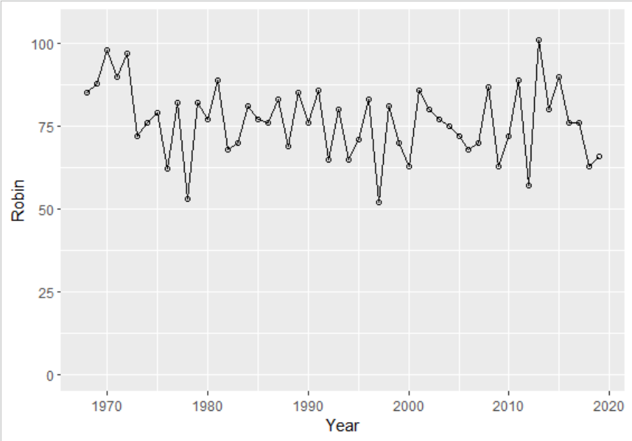

The numbers seem to fluctuate within a limited range of about 50 to 100. Is there some density - dependence?

The data file is available on Canvas: 4BirdsNashvilleMI.csv .

Download it and place it somewhere you can find it. Also download the code in the script file PopRegnLab24.R .

If you do not already have the Package “readr” you will need to install it and load it by running the first 4 lines of the code.

Then go to File … Import Dataset … choose “**From Text (readr)**”, then browse for the file. Similar access is provided via the Environment window. A preview will show.

Note that for the code to work, when you read the file it must be stored as a dataframe called X4birdsNashvilleMI. Check your success by looking at the Global Environment at upper right of R Studio for the file and its variables.

To test the hypothesis that robin population size is regulated by density dependence, you will use the code provided in the script file PopRegnLab24.R. First, add a line to the code at about line 9 to calculate the average (mean) number of robins over the time interval. (Recall how to do this from the Intro to R lab.)

**Q 1.1** What is the mean population size of robins from 1968-2019?

**Q 1.2** Which of the following options best describes the equilibrium value you will identify on the graph of Nt+1/Nt as a function of N? (Choices on Gradescope)

**Q 1.3.** Using the code provided in the file PopRegnLab24.R, run the code down to line 28 to see the plot of Nt+1/Nt versus time. What does this show? (choices on Gradescope).

**Q. 1.4** Now, use the rest of the code to create the graph of Nt+1/Nt as a function of population size, perform a linear regression and place the regression line on the graph. Add your names to the title and draw an arrow to indicate the position of the equilibrium point. You may draw your arrow indicating the equilibrium on the graph using anything you like (e.g., export and annotate the image), or try the arrows command in R:

arrows(x1, y1, x2,y2)

draws an arrow from x1, y1 to x2, y2 – replace the variables with the appropriate numbers.

*Optional self-check 1. What would you get in the second plot if there is no density-dependence?*

Be sure that your names are in the plot title, save it as a gif, png, or pdf, and upload the image to Gradescope.

**Q 1.5** Does your analysis indicate that the robin population is regulated by density-dependent factors? Justify your answer with reference to the plot you uploaded and the mean population size you calculated for Q1.1.

**Q 1.6** A pair of robins can build several nests per year in the forks of trees, but fledgling success is low. They mostly forage on the ground for worms and insects, and eat berries of shrubs and trees when invertebrate prey become scarce. What factors might be behind the density-dependence of their growth?

# Birth and Death rates

Time series data cannot tell us much about the particular factors regulating a population, but models that incorporate density dependence allow us to quantify relationships between population abundance and birth and death rates.

Recall the basic population growth equation:

*ΔN=(b−d)⋅Nt*Equation 1

In this exponential growth model, we assume that the per capita birth and death rates, *b* and *d*, are constant, and thus that the per capita population growth rate is constant (i.e. not density-dependent). To model population growth with density dependence, we want these rates to be functions of abundance. Equations 2 and 3 below model birth and death rates as linear functions of abundance. In particular, as abundance goes up, *b* goes down because resource limitation is likely to reduce fecundity.

*b=bmax−a∗Nt* Equation 2

For the death rate *d* we might expect it to go up as abundance goes up due to resource limitation:

*d=dmin+c∗Nt* Equation 3

*Optional self-check 2: Rewrite equation 1 with density-dependence.*

The above equations nicely illustrate the meaning of density dependence. That is, one or more vital rates are dependent on density! The constants *a* and *c* measure the strength of density dependence. *b max* and *dmin* are the maximum and minimum per capita birth rates and death rates.

*Optional self-check 3: if the birth rate is less than maximal at low densities, how would that look? Make a sketch-graph.*

At what abundance will growth stabilize? When *ΔN=(b−d)⋅Nt =0*, which occurs when *b = d*. If we plot birth and death rates as a function of population size, this equilibrium corresponds to the population size at which the birth and death lines or curves cross each other.

We can visualize these density-dependent effects with the following code, found in the file Pop.Flow.R on Canvas.

**First, run all the lines of code to set up the function.**

To evaluate the effects of changing the model parameters, change the values of *b, d, a* and *c* in the last line of code, and run just that last line. Since we have assigned the name “pop.flow” to the function in the earlier lines, running the final line will run all the statements included in the function.

Try changing the parameters a few times, re-running the function each time.

**Q 2.1** What are the arrows in the figure pointing towards? (Choices on Gradescope)

# Define the Rates function

pop.flow = function(b,d,a,c) {

# Population size

N = seq(0,100,5)



# Define per-capita birth and death rates where b = b(max) and d=d(min)



pcbr = b - a*N

Add non-linearity here for 2.6



pcdr = d + c*N



# Plot per-capita birth and death rates as a function of N

plot(N,pcbr,type='l',col='blue',lwd=2,ylim=c(min(c(pcbr,pcdr)),max(c(pcbr,pcdr))),xlab='Population Size (N)',ylab='Rate')



lines(N,pcdr,col='red',lwd=2)



legend(0.5,max(c(pcbr,pcdr)),c('p-c birth rate','p-c death rate'),pch=15,col=c('blue','red'))

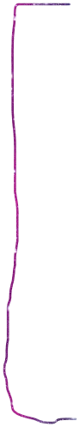



# Add flow information



text(1,(1-0.25)*min(c(pcbr,pcdr)),'Flow',cex=1.5)



for (i in 1:length(N)) {

loc = i

if (pcbr[loc] > pcdr[loc]) {

text(N[i],min(c(pcbr,pcdr)),'>',cex=1.5)

}

if (pcbr[loc] < pcdr[loc]) {

text(N[i],min(c(pcbr,pcdr)),'<',cex=1.5)

}

if (pcbr[loc] == pcdr[loc]) {

text(N[i],min(c(pcbr,pcdr)),'--',cex=1.5)

}

}

}



# Plug in parameter values and run

Where to run the function, change parameters

pop.flow(b = 0.8, d = 0.2, a = 0.01, c = 0.01)



Let’s use some real data in these equations. The Mandarte Island song sparrows have been well studied. Mandarte is a small uninhabited island between Vancouver Island and the mainland, and complete censuses of nests and survival rates of adults were taken for 15 years. You can find these in a file “Mandarte Sparrows.csv” on Canvas.

You will need to find the values of *bmax, dmin, a* and *c* by fitting equation 2 and equation 3 to these data (using linear regressions). That is, you will perform linear regressions to estimate the slopes (*a* and *c*) and y-intercepts (*bmax*and *dmin*) for equations 2 and 3. Follow one of the two methods below to fit these linear models to the sparrow data:

A. The easiest way to find the slope and intercept is to use the LINEST function in Excel or Sheets, so you don’t need to read the Mandarte sparrow data file into R at all. The function is:

=LINEST(known_ys, known_xs, [const], [stats])

where const and stats are optional logical values.

If you give it a list of y-values and matching x-values as ranges (e.g. a1:a5, b1:b5) it computes the slope and intercept and places them in two cells. If you specify “FALSE” for [const] it will force the line through the origin 0,0. You will want to do that if your intercept is a negative value in the death rate line.

B. You can use R and the regression (lm) code (see the steps in PopRegnLab24.R and be careful to skip the first line when importing the data and specify that the variables are numeric). Note that if an intercept is negative, you will instead want to force the line through zero. To force the line through 0 in R:

birds.lm <- lm(y~ x, data = birds)

birds.lm2 <- lm(y~ 0 + x, data = birds) *# Adding the 0 term tells the lm() to fit the line through the origin*

**Q 2.2** What are the values you found for *bmax, dmin, a* and *c*?

**Q 2.3** Now use these values to generate a graph using pop.flow.

Put your names on the graph (add title(main = "our names") and upload it to Gradescope.

**Q 2.4** How does the equilibrium number apparent in the pop.flow graph, compare to the average number of female birds on the island?

With a little algebra, (you can see it [here](https://jdyeakel.github.io/teaching/ecology/section9/), just calculating the intersection point of the lines) it can be shown that the carrying capacity, K is equal to:

$K =\frac{bmax - dmin}{a + c}$ Equation 4

**Q. 2.5** Plug your values for *bmax, dmin, a,* and *c* into equation 4 to calculate the carrying capacity. Enter a number to one decimal place on Gradescope.

Note the similarity to the long-term average population size.

## Nonlinear birth and death rates

What if the birth or death rates are not a linear function of the density? You can easily think of situations where that would be true: if it gets harder to find mates as the density decreases, or if animals cooperate to catch prey or spot predators, such that at intermediate densities they survive better than at lower densities. We can turn the linear functions of equations 2 and 3 into polynomials.

*b=bmax−a∗Nt --> bmax−a∗Nt – f * Nt2*



*d=dmin+c∗Nt --> dmin+c∗Nt – g * Nt2*



For the Mandarte sparrows, the equations we fit are:

*b = 4.63 – 0.026 Nt - 0.0003 Nt2*

*d = 0.56 - 0.048 Nt + 0.0018 Nt2*

**Q 2.6** Modify the code of pop.flow above to plot the graph with the polynomial lines instead of the linear relationship. (Hint: lines 8-10 are where you should be looking & since you will only do this for the one situation, you don’t need to make new variables (f & g) for the function —just include the numerical values of f and g in the equations you modify.) Of course, also change the a, b, c, and d values in the last line of code!

Upload the graph to answer this question with your names in the title.

# Answers to self-check questions

1. You would get a cloud of points with no trend to them.

2.

3. 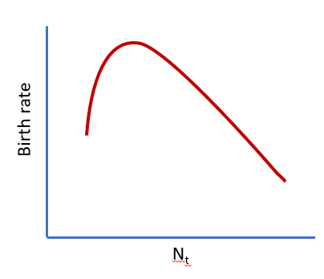

## References Cited:

Ziolkowski Jr., D.J., Lutmerding, M., Aponte, V.I., and Hudson, M-A. R., 2022, North American Breeding Bird Survey Dataset 1966 - 2021: U.S. Geological Survey data release, https://doi.org/10.5066/P97WAZE5.